Homework 4  
Statistical Inference

**PREPARED BY**

Mohsen Fayyaz - 810100524

Winter 2021

**فهرست مطالب**

**Q1** **3**

Determine if the following statements are true or false, and explain your reasoning for the statements you identify as false. 3

**Q2** **6**

Consider the following ANOVA table for between-subjects with 25 total subjects. Fill in missing parts. Are the results significant? What is the conclusion? 6

**Q3** **7**

(R) Student t-test is used to compare two groups, ANOVA generalizes the t-test beyond two groups, so it is used to compare three or more groups. You have to install the built-in “penguins” dataset in R. 7

**Q4** **13**

**Q5** **15**

**Q6** **17**

**Q7** **18**

**Q8** **19**

Find confidence interval of parameter θ for each probability density function (𝛼 𝑖𝑠 𝑘𝑛𝑜𝑤𝑛): 19

**Q9** **20**

**Q10** **23**

(R) Answer the following questions considering this Dataset. 23

**FEEDBACK:** **30**

# Q1

## Determine if the following statements are true or false, and explain your reasoning for the statements you identify as false.

a. ANOVA is robust with violations to assumptions of homogeneity of variance, so if you fail Levene’s test (Normality condition) by a small amount, you’re still ok

True  
assumption can be a little violated except when groups have unequal number of subject test with Levene’s test for homogeneity of variances. with violations of homogeneity the analysis is considered robust if you have equal sized groups.  
ANOVA is fairly robust in terms of the error rate when sample sizes are equal. However, when sample sizes are unequal, ANOVA is not robust to violations of homogeneity of variance.  
If we violate one or more of the ANOVA test assumptions, the results of the analysis may be incorrect or misleading

b. F ratio has no Negative values and is positively skewed.

False  
The F-ratio is the ratio of the between group variance to the within group variance. It is not a distribution to be skewed. F distribution is always positive and right skewed.

c. Large mean differences and small sample variances in ANOVA, are most likely to produce a large value for the F-ratio.

True  
Group mean differences is the between group variance which is the numerator and is positively related with F. Moreover, sample variances is within group variance in the denominator which has reverse relation to F.

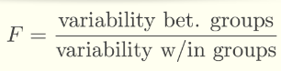

d. In ANOVA, the More variance within the groups, the greater the noise (variance).

True, we like the variance within the groups to be smaller so that the noise (variance) is small so that the groups are more distinct.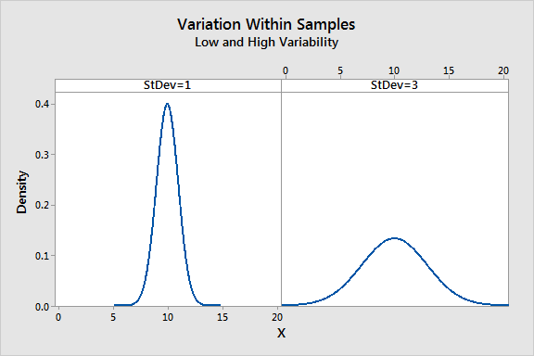

e. A researcher reports an F-ratio with df = 3, 36 for an independent-measures experiment. 39 individual subjects participated in the experiment?

False, n=40

$df_{Total}=n-1$ $df_{Group}=k-1=3⇒k=4$ $df_{Error}=df_{Total}-df_{Group}=n-k=36⇒n-4=36⇒n=40$

f. Let’s assume that the main sample is (39, 61, 43, 55, 48); a bootstrap sample would be like: (43, 39, **56**, 43, 61)

False  
Bootstrap sample is a random sample taken with replacement from the original sample. However, 56 here is not available in the original sample which cannot happen.

g. Consider this hypothesis test, 𝑥̅1 = 3.75, 𝑠1 = 5.25251, 𝑛1 = 20, 𝑥̅2 = 5.25, 𝑠2 = 2.33735, 𝑛2 = 25; the exact 95% CI would be 1.5 ± 2.09 × 1.26408.

True  
Estimating the difference between independent means: $SE_{(x_{1}-x_{2})}=\sqrt{\frac{{s_{1}}^{2}}{n_{1}}+\frac{{s_{2}}^{2}}{n_{2}}}=\sqrt{1.37+0.21}=1.26$ $df=min(n_{1}-1, n_{2}-1)=min(19, 24)=19$ $t_{df}=qt(0.025, df = 19)=2.09$ ${(x}_{1} − x_{2}) ± t_{df}∗ SE=1.5 ± 2.09×1.26$

h. Someone wants to investigate the visual memory in boys and girls under 17; the valid result is the outcome of a paired t-student test.

False  
When two sets of observations have a special correspondence (not independent), they are said to be paired. However, the boys group should be independent from the girls group in this experiment.

i. If we use not paired t student test for two correlated groups, we are decreasing the power of the test.

False?  
Not paired t student test must meet the condition of independence between groups i.e. the two groups must be independent of each other (non-paired). So we cannot even use not paired t test for correlated groups.

j. When comparing means of two samples where 𝑛1 = 20 and 𝑛2 = 40, we can use the normal distribution for the difference in means since 𝑛2 ≥ 30.

False  
DF for 𝒕 statistic for inference on two means: df=min(n1-1,n2-1); therefore, we should consider n1 which is $20≤30$ and this we should use t student with df = 20 which is not yet comparable to normal.

k. Suppose the null hypothesis that the means of four groups are all the same is rejected using ANOVA at a 5% significance level. In that case, The pairwise analysis will identify at least one pair of means that are significantly different.

True  
If p-value is small (less than 𝛼), reject 𝐻0: The data provide convincing evidence that at least one pair of population means are different from each other (but we can’t tell which one).

# 

# Q2

## Consider the following ANOVA table for between-subjects with 25 total subjects. Fill in missing parts. Are the results significant? What is the conclusion?

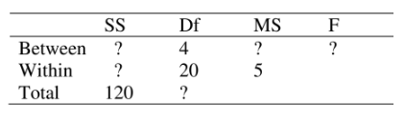

|  | SS (Sum Sq) | Df | MS (Mean Sq) | F |
| --- | --- | --- | --- | --- |
| Between (Group) | $SSG$ $=Total-SSE$ $=120-100=20$ | 4 | $MSG$ $=\frac{SSG}{df_{G}}$ $=\frac{20}{4}=5$ | $\frac{MSG}{MSE}=\frac{5}{5}=1$ |
| Within (Error) | $SSE$ $=MSE×df_{E}$ $=5*20=100$ | 20 | $MSE=\frac{SSE}{df_{E}}=5$ |  |
| Total | 120 | $4+20=24$ |  |  |

F=1,   
pf(q=1, df1=20, df2=100, lower.tail=FALSE)  
0.469209  
The p-value is large, so the results are not significant.  
p-value is large; hence, we come to the conclusion that we fail to reject 𝐻0.

# Q3

## (R) Student t-test is used to compare two groups, ANOVA generalizes the t-test beyond two groups, so it is used to compare three or more groups. You have to install the built-in “penguins” dataset in R.

a. We only need two-column. Select flipper length and the species.

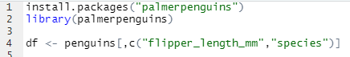

b. Plot(using ggplot2) flipper length of each species.

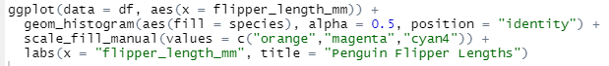

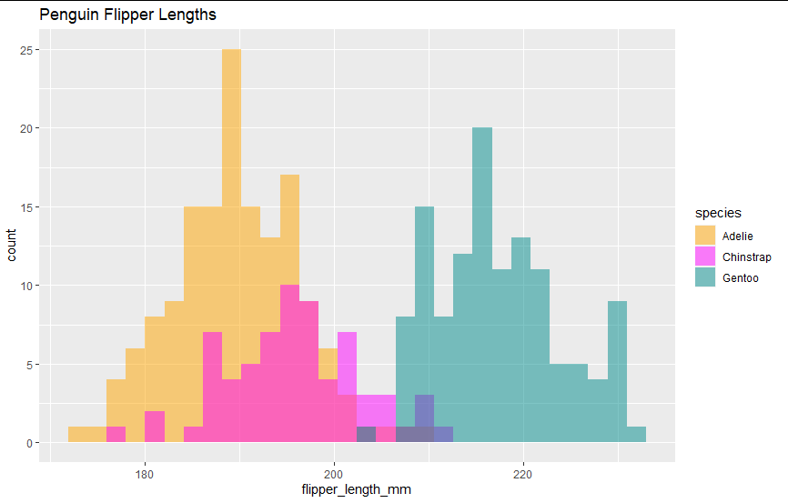

c. Check assumptions of ANOVA. Plot normality assumption.

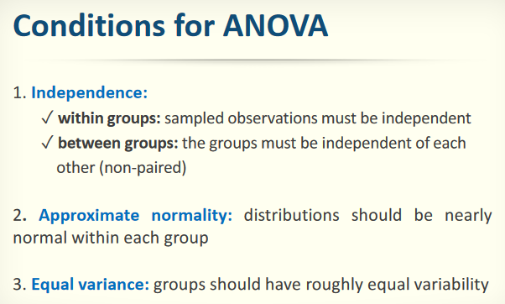

1. Independence
   1. Within
      1. random sample / assignment
      2. each 𝑛𝑗 less than 10% of respective population
   2. Between
      1. groups must be independent of each other
2. Approximate normality  
   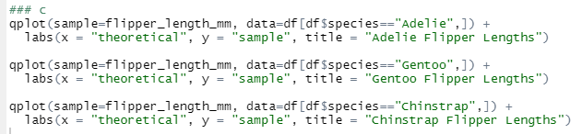

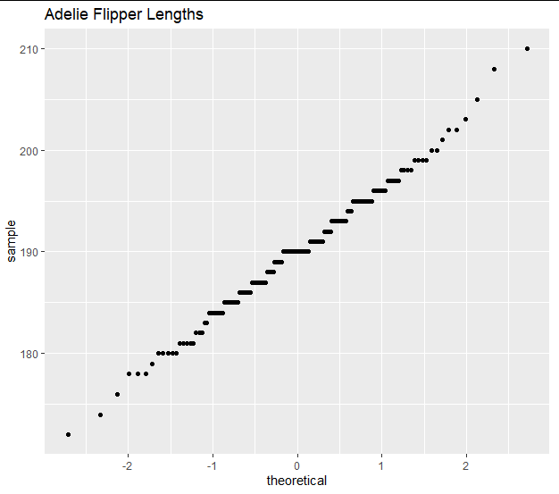

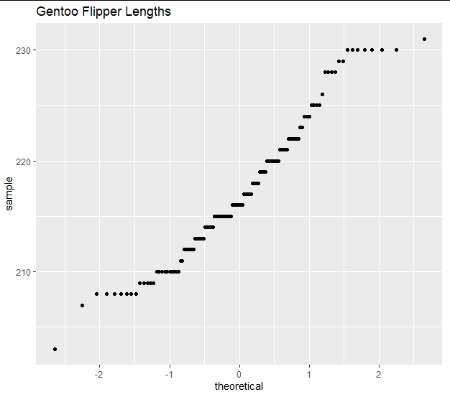

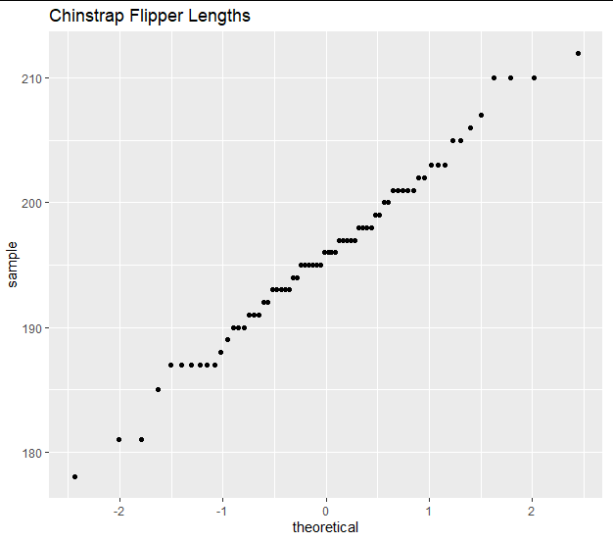

1. Equal variance



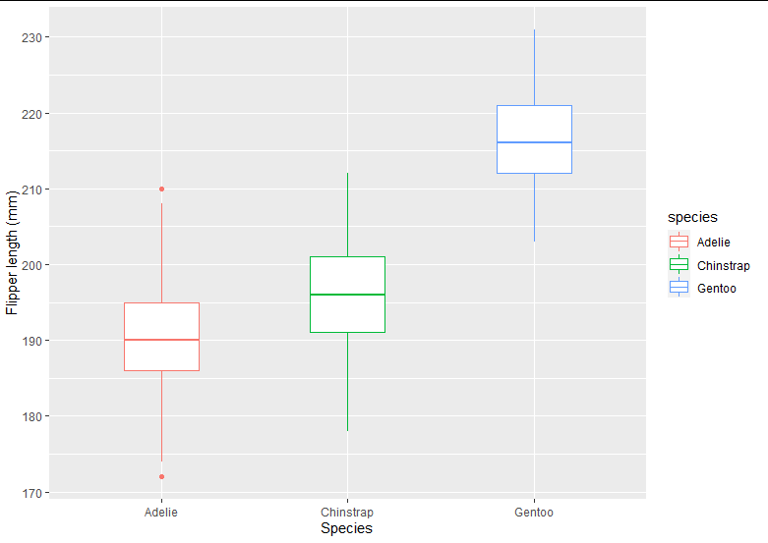

d. Plot Equality of variances (instead of boxplot, use dotplot).



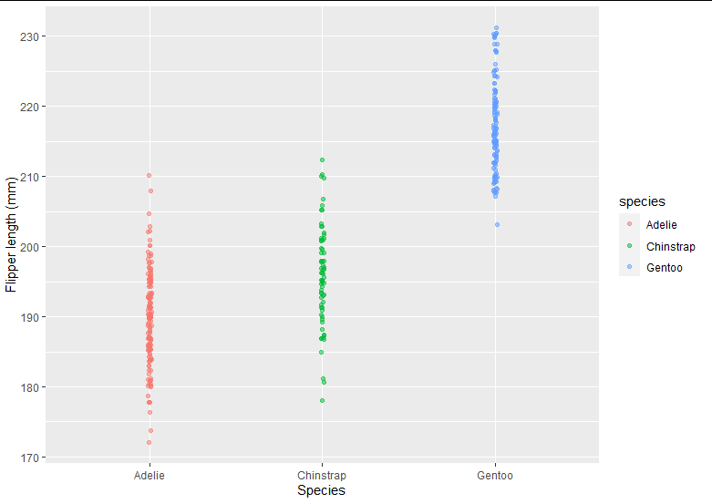

e. Summarize descriptive statistics(mean and sd of each species based on their flipper_length) as a table.

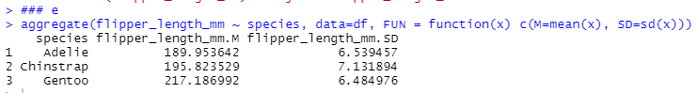

f. Do ANOVA test. Interpret and show the r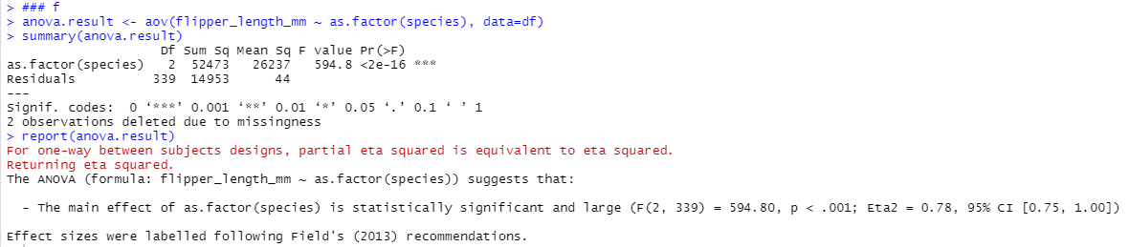esult using the “report” library.

There is something statistically significant going on here as p(>F)<2e-16 is small.

g. How many comparisons do we have if we want to use multiple comparisons? What is Bonferroni correction for alpha?

We have 3 classes therefore we can have $c(3, 2)=\frac{3!}{2!}=3$ comparisons.   
If we have multiple tests → inflated Type 1 error rate  
To solve this we use modified significance level.  
The Bonferroni correction suggests that a more stringent significance level is more appropriate for these tests Adjust 𝛼 by the number of comparisons being considered:

𝛼∗ = 𝛼/𝐾=0.05/3 = 0.0166

𝐾 : number of comparisons  
𝐾 = 𝑘(𝑘 − 1)/2 = 3

# Q4

A committee wants to investigate the perfect average age in Iran’s national basketball team; the perfect interval of average age is an interval that guarantees that the players are not too old or too rookie for the job. Let us assume they gathered 50 samples from the national team players’ information. The committee wants to compare the national team data with a sample of 40 observations of a team that believes it is a perfect aged team. Here you come as a data specialist:

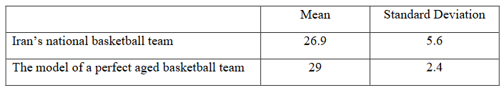

a. What would you conclude from this data? (α=0.05)?

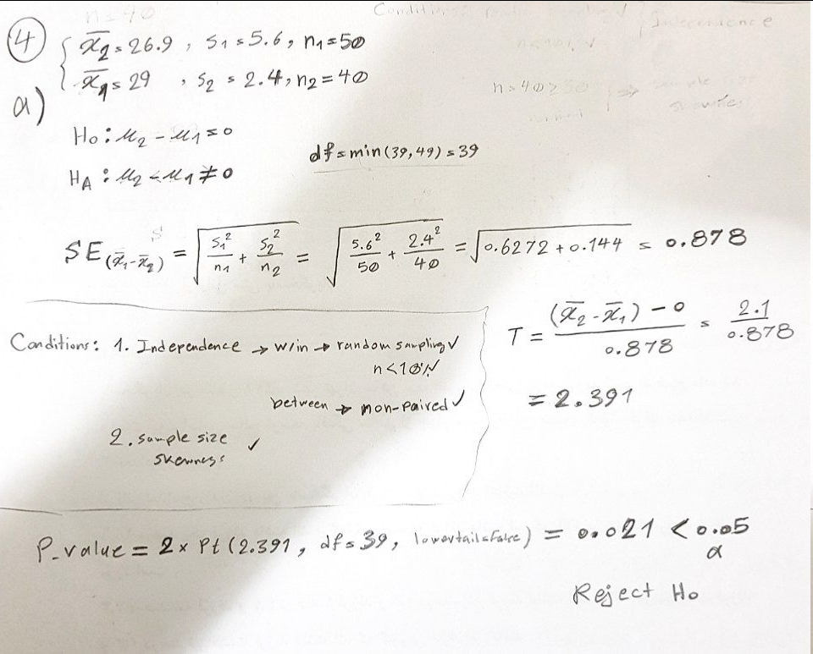

By comparing the national team data with a sample of 40 observations of a team is believed to be a perfect aged team, we concluded that we can reject the null hypothesis meaning the difference is statistically significant.

b. If the average age of a perfect team is 28, what is the probability of type-II error?

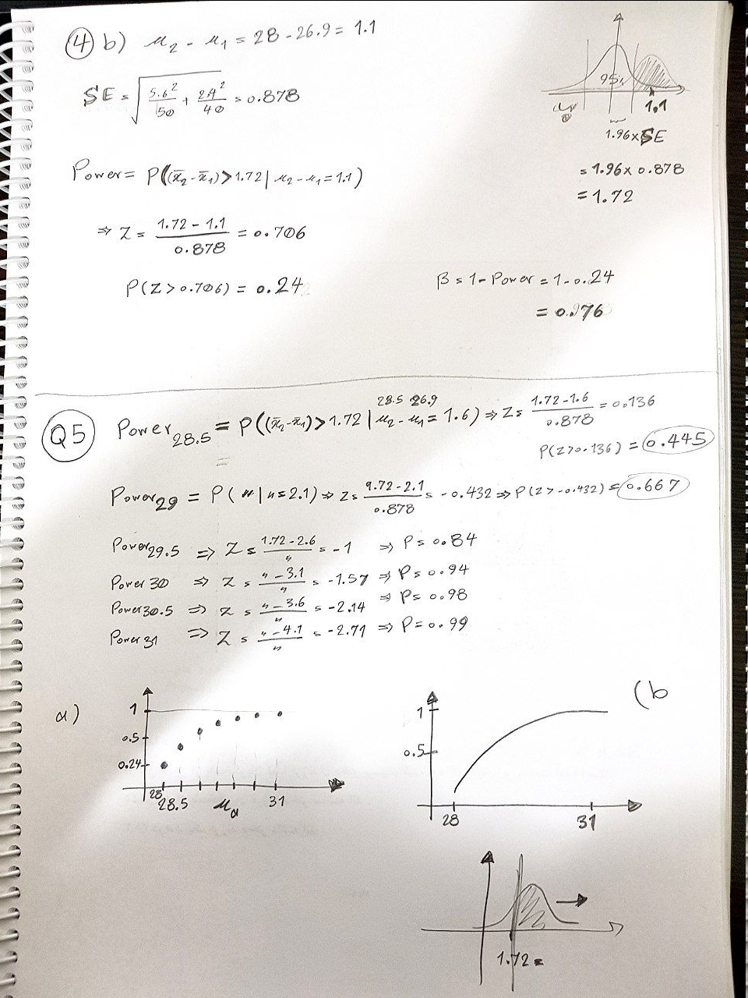

c. Identify if there is a possibility you made a type-II error in answering part (a)?

A type 2 error describes the error that occurs when one fails to reject a null hypothesis that is actually false. A type II error produces a false negative. In part a we rejected the null hypothesis. Hence, we can have type 1 error where we failed to not reject a null hypothesis that is true.

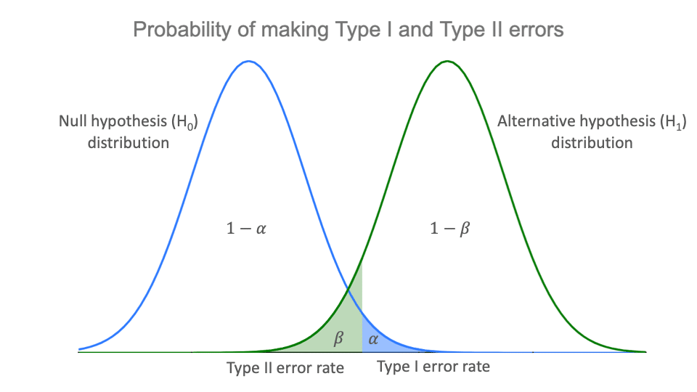

# Q5

In the previous question, calculate the power of estimate to reject the committee null hypothesis. Consider the estimated perfect aged team be: 28.5, 29, 29.5, 30, 30.5, 31. (Note: You have to do it by hand to compute the power.)

a. Plot the power curve.



b. Interpolate the powers that you calculated. (Explain the increase or decrease of the curve)

Plot in a  
As the ma increases, the distribution mean shifts to right and increasingly the power which is the area on the right side of the rejection threshold increases as shown in the plot.

c. Assume the sample size is constant, now change the α to 0.01, without any computation, estimate the curve. (Your answer may not be accurate.)

As α decreases the threshold for rejection shifts to the right. Hence the power decreases compared to the last α and the curve will be under the previous curve. (Or we can say that the new curve is the previous curve shifted right.)

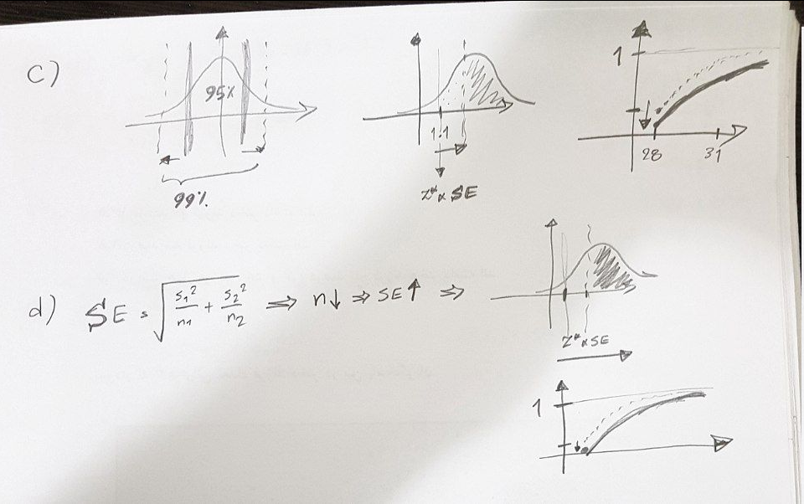

d. Change both sample sizes to 20, then repeat part (c).

Reducing the sample size will increase SE and therefore the threshold for rejection shifts to the right and power decreases compared to the last α and the curve will be under the previous curve. (Or we can say that the new curve is the previous curve shifted right.)



# Q6

We recorded a sample of people in Ali Shariati’s speech in two different scenarios: the events without any catering and the events with catering; assume that the sample is fair and a good representative. Use a statistical test to investigate that if the catering did attract more audience to his speeches overall. Consider 𝛼 = 0.05. If you couldn’t reject the null hypothesis, determine how much can you increase 𝛼 approximately? (You are not allowed to use R.)

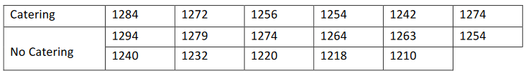

Catering 1284 1272 1256 1254 1242 1274

No Catering 1294 1279 1274 1264 1263 1254  
1240 1232 1220 1218 1210

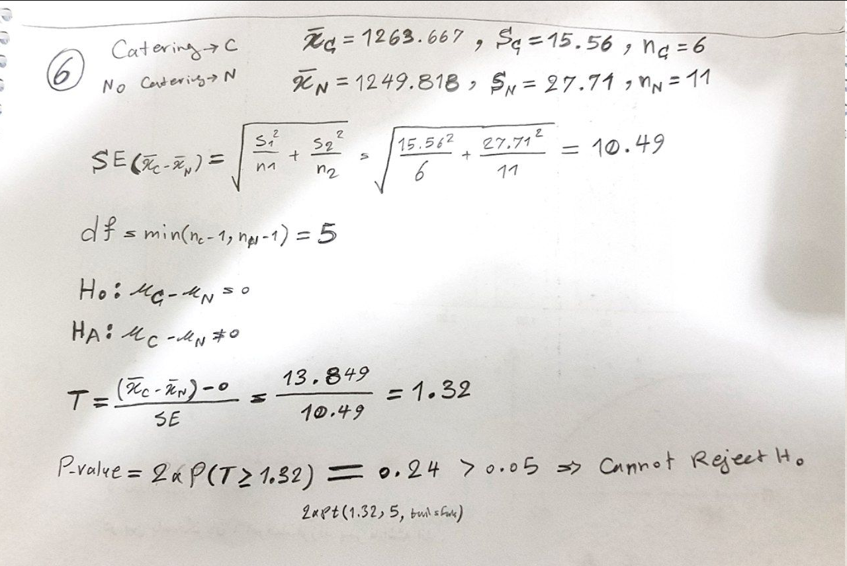

If we want to increase 𝛼 to reject (which does not seem reasonable) we need to increase it up to 0.24 which is the calculated p-value.

# Q7

A leading tech company has used an AI method in some of its products. We want to measure if there are any differences between the two methods so, we gathered scores from 15 users as below. Test the hypothesis.

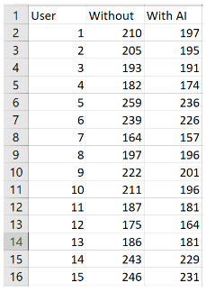

As the users are the same in the two experiments, it is similar to the writing test in the course and they are paired; hence, To analyze paired data, it is often useful to look at the difference in outcomes of each pair of observations: diff = w/oAI - w/AI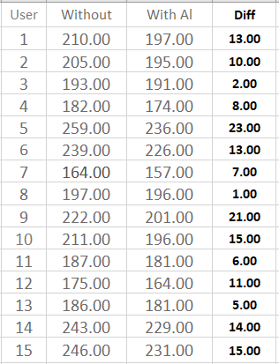

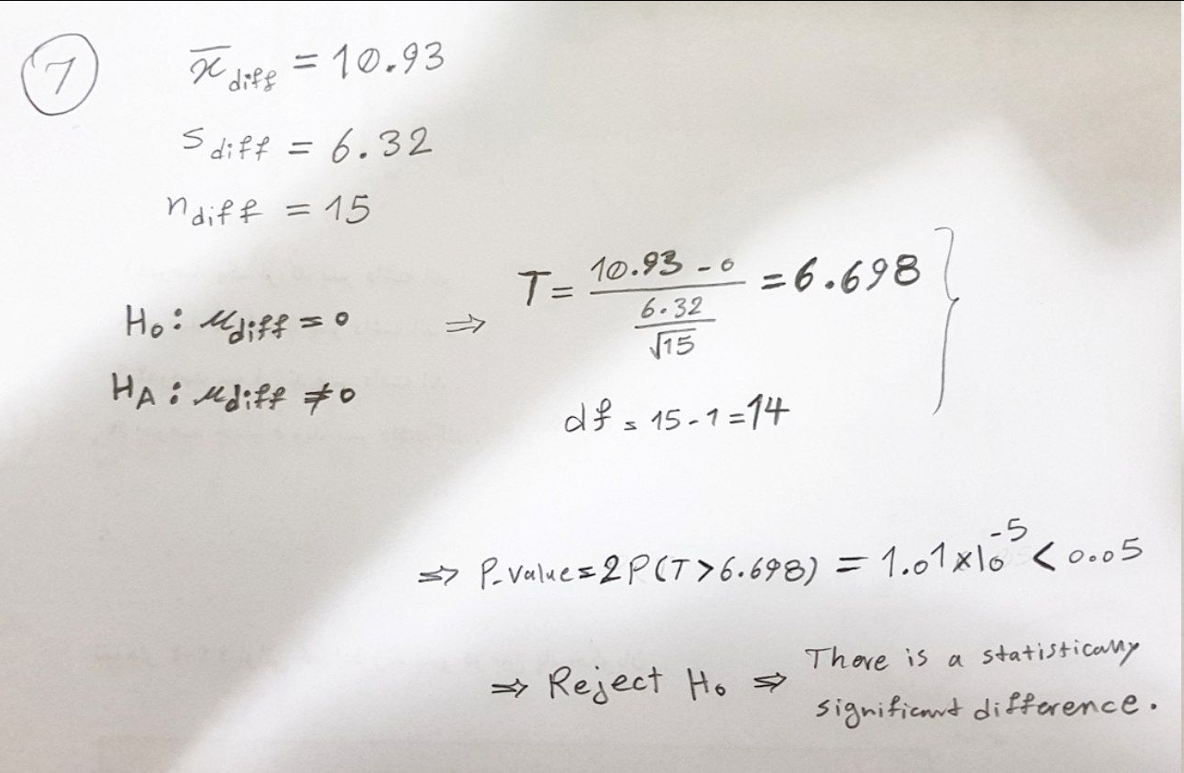

# Q8

## Find confidence interval of parameter θ for each probability density function (𝛼 𝑖𝑠 𝑘𝑛𝑜𝑤𝑛):

There has been no sample about this question in the course!

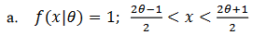

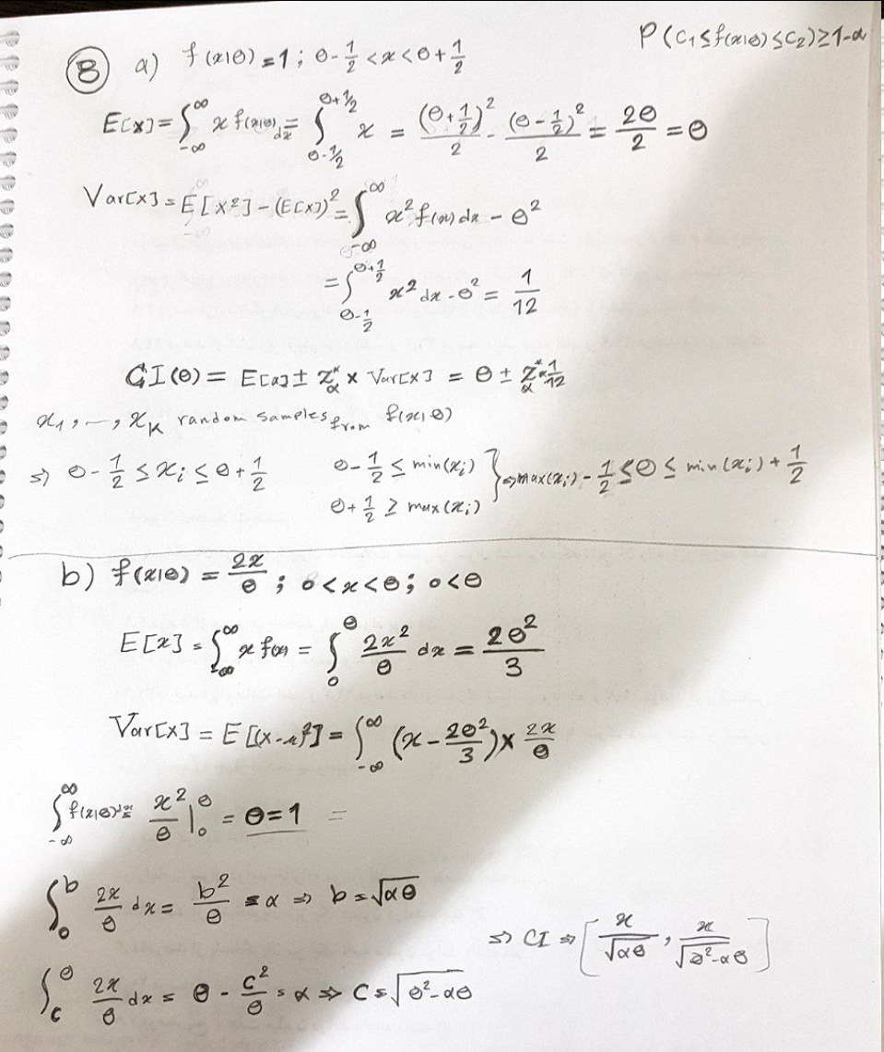

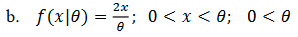



# Q9

A university in Guinea Bissau wants to estimate overall performance; Hence, some research groups’ published the below table as a result. They have assumed that if the overall performance is below 35 papers per year, they must shut down the university.

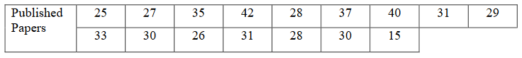

Published Papers  
25 27 35 42 28 37 40 31 29  
33 30 26 31 28 30 15

a. Assuming the one-year periods are fairly typical of the volumes throughout the years, is there significant evidence that the average published paper is greater than 35? Compute the p-value for the test statistic. What is the 95% CI?

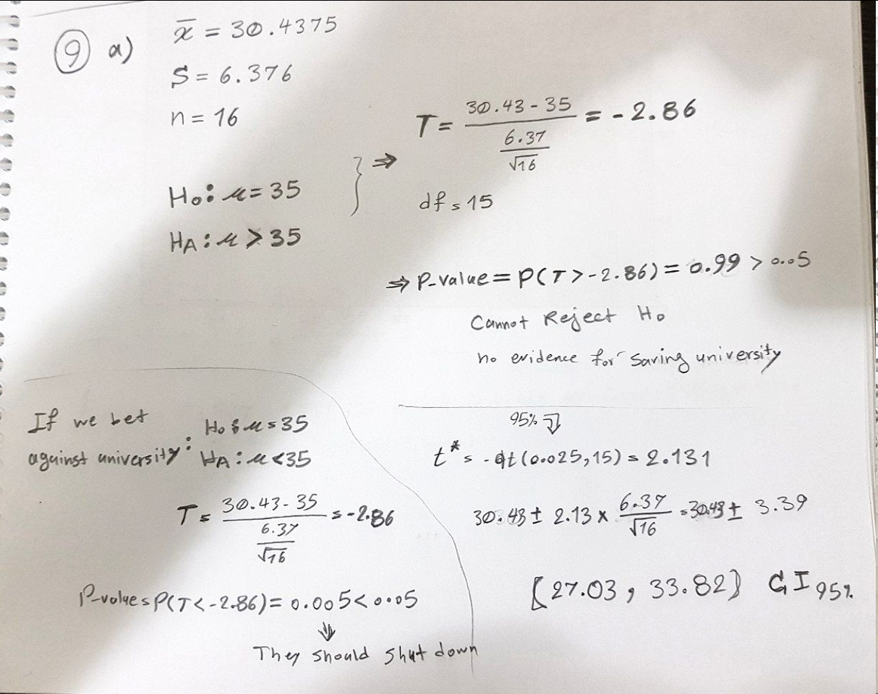

b. (R) Use R to obtain 1,000 bootstrap samples from the data in the table below. Use these 1,000 samples to get the bootstrap p-value for the t-test of the hypothesis that ends up surviving university. Explain your answer.

Repeat 1000 times: Take a bootstrap sample - a random sample taken with replacement from the original sample, of the same size as the original sample and calculate the bootstrap statistic, which is mean here. Then we get the distribution as shown in the bar plot. Then we compute the p-value for the t-test with H0 being m=35 and HA being m>35 so that we can save the university. We compute t statistic based on means and SE and the p-value for being greater than T is computed using pt and with df of 1000-1 and as we can see it is very high and we cannot reject H0 nor save the university. This can also be observed in the histogram, where the values are mostly less than 35.

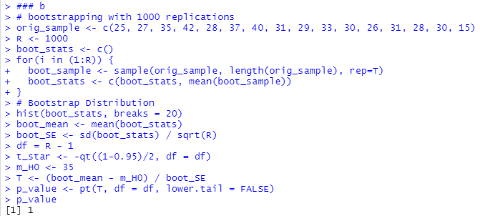

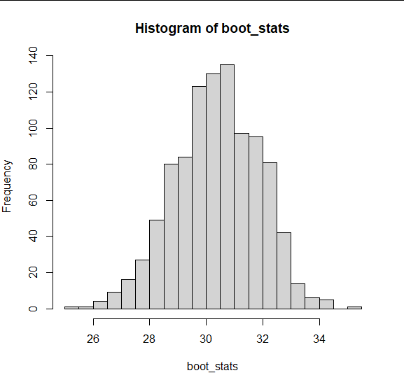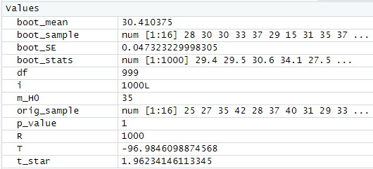

c. (R) Use the bootstrap data to compute the p-value and the CI, compare it with part (a)

  
Here mean instead of median.

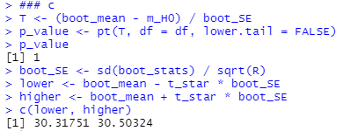

As n has increased here the SE decreases and therefore we end up with a smaller CI, and also this will increase p_value here a little bit. For p_value if we used 30 as the H0 we would get 8.491184e-18 and we could have rejected the null hypothesis and saved the university but 35 is too high for these observations.

# 

# Q10

## (R) Answer the following questions considering this [Dataset](https://www.kaggle.com/irfanazeem/used-cars-sale-price#car_train.csv).

a. Choose a numerical variable.

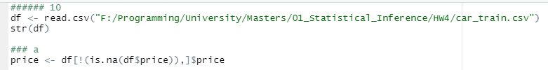

i. For the mean value of this numerical variable, design a hypothesis test and by finding the p-value, confirm or reject your assumption. Interpret this p-value.

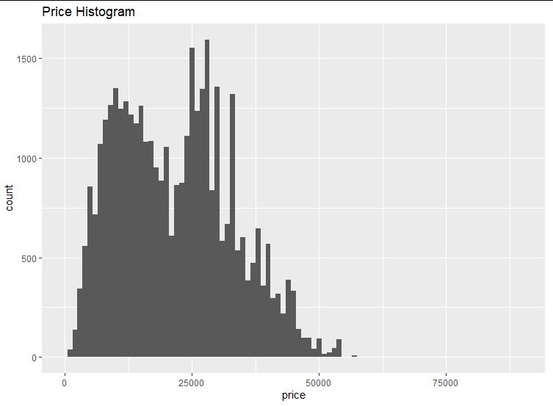  
Mean of this sample is 22170.48. Let the m0 be 21,000 and we hypothesize that it is more than 21,000.  
H0: m=21000  
HA: m>21000  
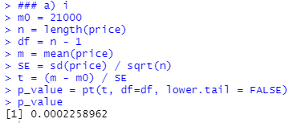

p-value=0.0002<0.05; hence, we reject H0 and m is greater than 21000.

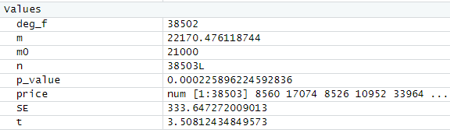

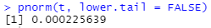

Also, as n is large and df is large t is close to z.

ii. Calculate a 95% CI for this numerical variable. Based on this confidence interval, do these data support the hypothesis that you have designed? Explain it.

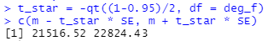

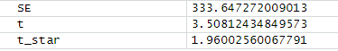

Because 21000 does not fall in this confidence interval we could reject the null hypothesis by this method. This is consistent with our test in i and reject H0 and m is greater than 21000.

iii. Calculate type II error.

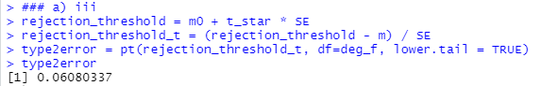

iv. Calculate the power and Explain the relationship between the power and effect size. (plot a curve)

Power = 1 - type2error

Clearly, 𝜷 depends on the effect size (𝛿), difference between point estimate and null value: 𝛿 = 𝑥 − 𝜇0. As power is 1-𝜷, it depends on effect size as well.

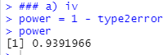

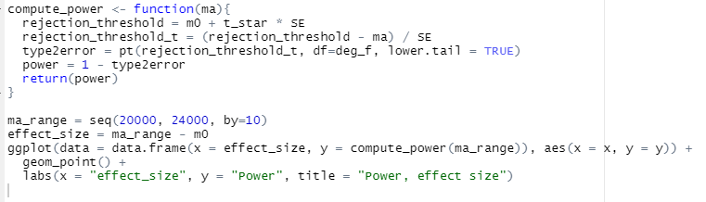

As effect size increases we get far from the rejection threshold and therefore more and more of the distribution with ma will be on the right side of it and therefore the power increases.

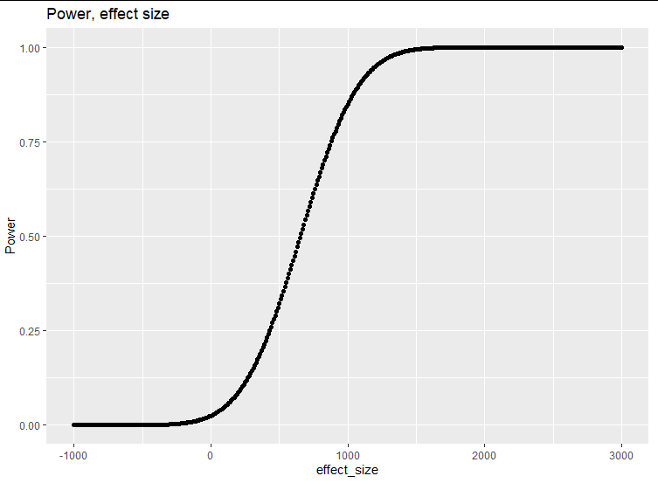

v. Choose a tiny sample, design a bootstrap scenario, and repeat (i) and (ii). Explain if there is a difference or not.

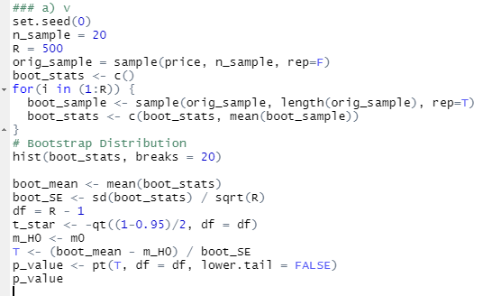

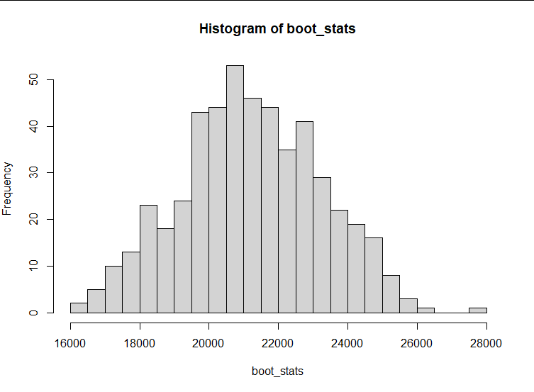

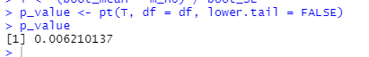

As p-value is less than 0.05 we reject the null hypothesis and the result is consistent with the previous parts.  


The CI also shows that 21000 is not in the CI and therefore we reject H0.

vi. If you have performed part (v) via the standard error method, repeat your test via percentile method and vice versa.

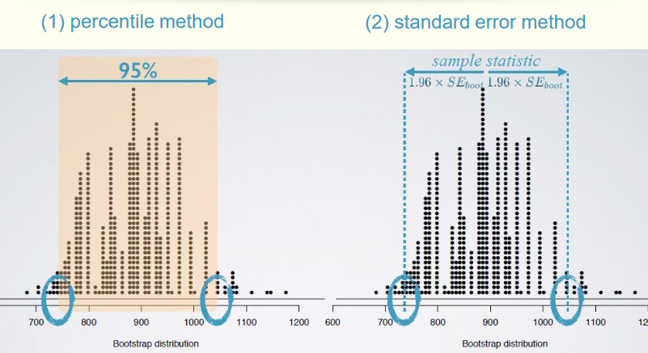

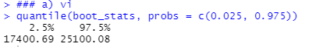

vii. Is there any difference between these two calculated CIs in part (vi)?

As mentioned in the videos these two are not necessarily equal and they can be different as they are here.

b. Conduct a hypothesis test for two numerical variables. Choose a random sample of 25 data points from the Dataset and choose two numerical variables, not of a corresponding quantity. We want to use this data to compare the average quantity between the two variables.

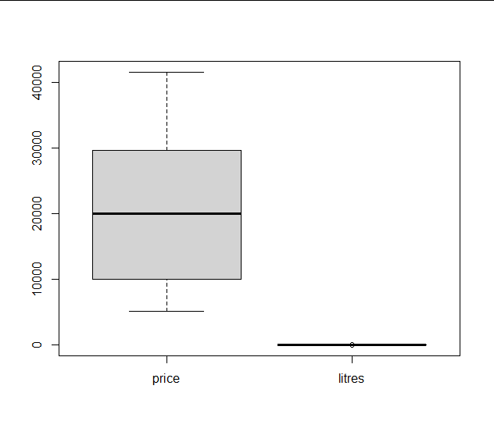

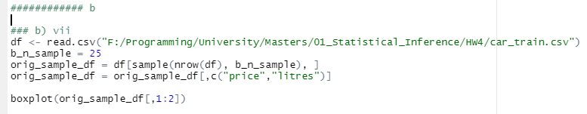

viii. Should we use a t-test or z-test? Explain why.

As n=25 is small (<30) we should use t-test with a specific degree of freedom to consider the possible noise and extend the CI compared to z test.

ix. Design a hypothesis test to see if these data provide convincing evidence of a difference between mean values. Does the result agree with the 95% confidence interval?

H0: m1-m2=0  
HA: m1-m2≠0

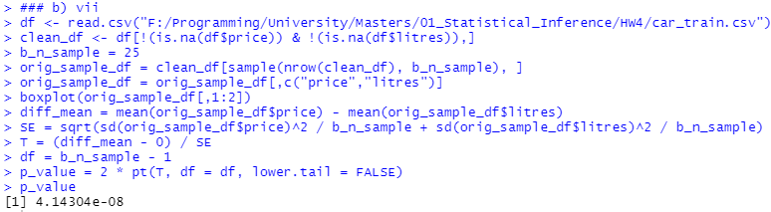

P_value is small (<0.025) so we reject the null hypothesis and the mean of these two have a statistically significant difference.

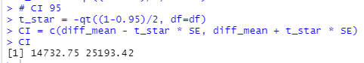

As 0 does not fall in this CI, we reject H0 and the result is consistent.

c. Are used cars with an automatic gearbox higher in the price? Is there enough evidence to prove this? (Your answer must be in detail.)

H0: m-m0=0  
HA: m-m0>0  
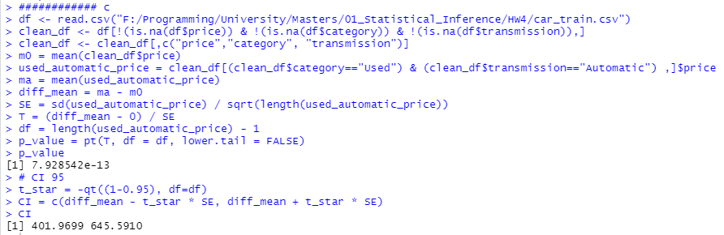

The P-value is very small (<0.05) which means we reject null hypothesis and therefore those cars are higher in price. This is also consistent with 95% CI where the difference of 0 does not fall in the CI meaning we can reject H0.

(Note: Use graphs and charts to clarify your answer and remember that the data might need a cleaning to pre-process.)

# FEEDBACK:

This homework specifically and also the ones before it have been so demanding and are too much both in quantity and difficulty (HW4 took me more than 10h). Fewer questions would give us more time to deeply think about the questions and learn with less stress about finishing the homework in time. Thank you for reading my feedback :)